COMM50 Postgraduate Study & Research Methods
Critiquing Research

Read the provided article:

Church, K. and de Oliveira, R., 2013, August. What's up with whatsapp?: comparing mobile instant messaging behaviors with traditional SMS. In Proceedings of the 15th international conference on Human-computer interaction with mobile devices and services (pp. 352-361). ACM)

Provide responses, with explanations, to each of the following statements and questions, making appropriate use of the guidelines on the next page by Coughlan, Cronin and Ryan (2007).

- Comment upon the elements influencing the believability of the research.

- What is the authors’ justification or motivation of the work?

- What are the specific aims or objectives of the research?

- How have the authors dealt with existing literature in the field? How do they use this to contribute to their paper?

- How would you describe the methodology employed in of the paper?

- Comment upon the selected methodology and explain why it has been selected, whether or not it allows the goals of the research to be met, and alternative approaches that could have been used.

- Can you identify any ethical issues or considerations in the authors’ work?

- What are the main findings or outcomes of the research?

- What are the main strengths and weakness of the paper?

- What utility or application does the research have in practice?

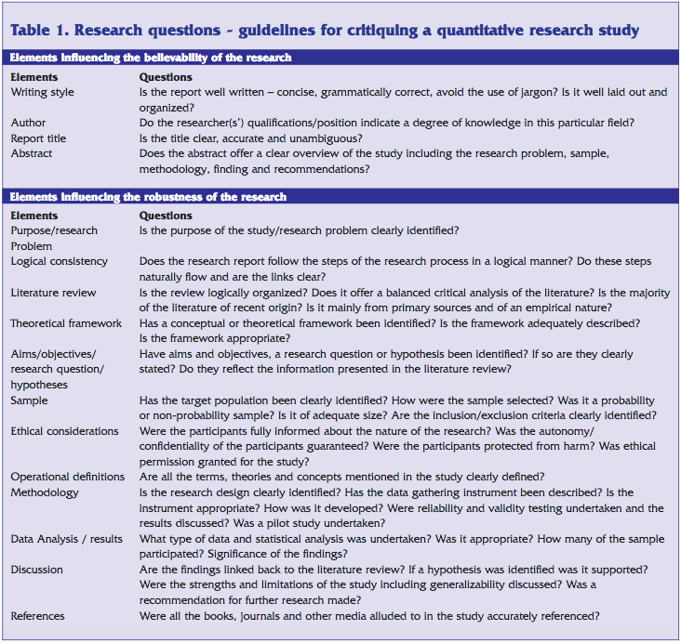

EXTRACTED FROM
Coughlan, M., Cronin, P. and Ryan, F., 2007. Step-by-step guide to critiquing research. Part 1: quantitative research. British journal of nursing, 16(11), pp.658-663.

